Rush F1 Website Development Portfolio
50056586
Josh Rush
Contents:
Introduction 1
Initial thoughts 1
Stack and structure 2
Design Planning 2
Homepage concept 2
Driver browse concept 3
Track browse concept 3
Team browse concept 3
Driver details concept 4
Track details concept 4
Team details concept 4
Development 5
Database 5
Database structure 5
Setting up the pages 6
Home page 6
Driver browse page 7
Driver details page 8
Team browse page 8
Team details page 8
Track browse page 8
Track details page 8
Testing and Review 8
Reflection and Conclusion 8

Introduction:
Initial thoughts:
When given the prompt of making a read only hobby website for this assignment, Formula 1 was an easy choice for me. It made sense considering that it was at the start of the season, so the stats and drivers would be accurate, and the website could be centred around the 2026 season itself. F1 being the hobby of choice made research easy as I knew where to look, and the research itself was fun rather than taxing. I had big ideas for the website and knew that my database would be full of content, so I had to pick what I included carefully. Things I knew I wanted to have for definite were drivers, teams and tracks, along with statistics and information about them.

Stack and structure:
The project itself, in the grand scheme of things, is rather straightforward with the stack used, but it allowed me to focus on its designed and functionality and to help me learn better. For the front-end, HTML was used, along with CCS for the styling instead of bootstrap, mainly because I wanted to have full control over the websites styling. I also thought that bootstrap may have made things a little easier than I wanted them to be, as in my opinion, it’s easier to learn when challenged. The backend is PHP using mysqli for all the server-sided logic and the communication with the database. The database (formuladb) is hosted with phpMyAdmin, using XAMPP, locally running on my computer with Apache and MySQL. It has three tables; drivers, teams and tracks which the site pulls its information from directly. I made sure to create a db_connect.php file early so that I didn’t have to repeat the connection code on every file.
Design Planning:
Before any design was implemented or thought about, I displayed all of the information in a table to ensure the database connection was working correctly, and when the database was updated with new information the site’s table needed to update accordingly. Early on I knew I wanted a main home page and individual browse pages for drivers, teams and tracks and I knew I wanted it to be minimalistic and easy to navigate so that users could quickly get to what they want to see. Each of the browse pages use boxes to display content, which was intentional to make things consistent and easy to navigate, both on desktop and mobile.
Below are some wireframes and concepts for each of the pages:
Homepage concept:
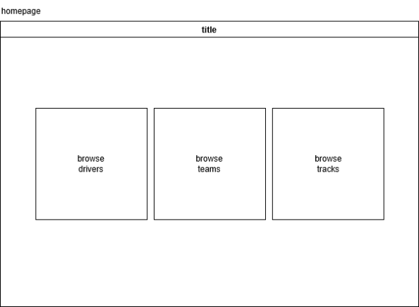
The design started out with square shaped browse buttons to get to the individual pages as I wanted it to be very simple and clean.
ref: img1
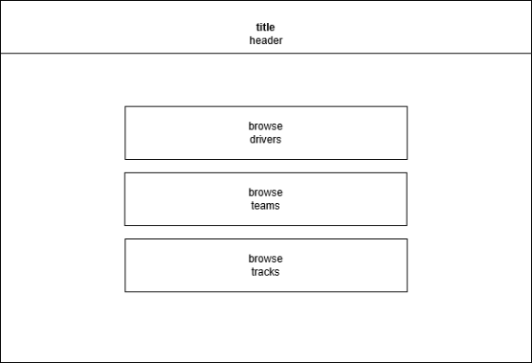
However, it quickly changed to more rectangular shaped buttons as it fit the minimalistic design better and filled the space more.
ref: img2
Driver browse concept:
The driver browse page carries on with the minimalistic “F1” style with the driver’s hero image, their name, their driver number and the team they race for. I think this works well and scales well on mobile.
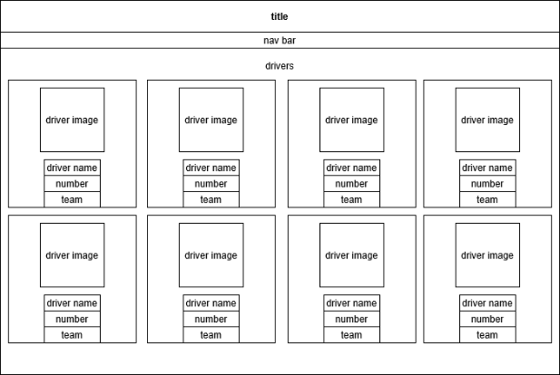
ref: img3
Track browse concept:
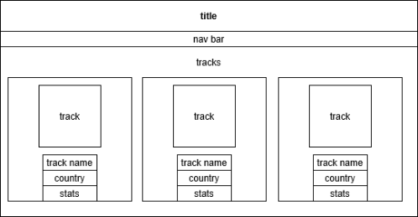
The track browse page continues with the same style for consistency, keeping the title and the nav bar for moving around the site. It showcases the track map, the name, the country of the track and some of its statistics.
ref:img4
Team browse concept:
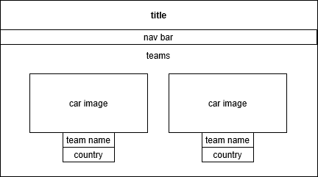
Team browse is much of the same for better consistency. The team’s car takes the centre stage, with the team’s name and team’s origin country underneath it.
ref:img5

Driver details concept:
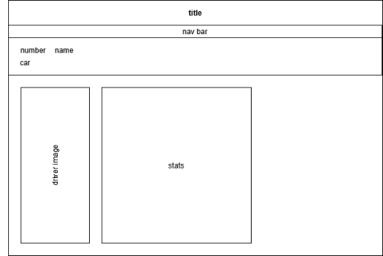
The driver details page started out left aligned with a big hero image of the driver and the stats on the right of it. The banner above the driver and stats has their car, number and name.
ref:img6
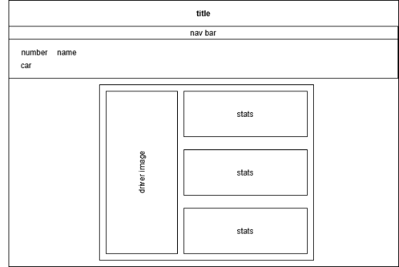
Before long I centred everything and outlined it with red to make it pop more. It also made the site look better both on desktop and on mobile.
ref:img7
Track details concept
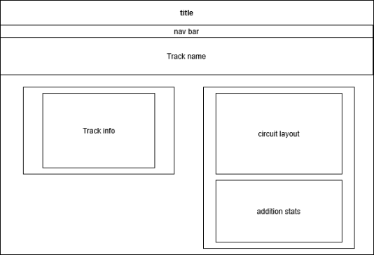
The track details page has its info, the official circuit layout and some additional stats such as lap record, most wins and attendance.
ref:img8
Team details concept
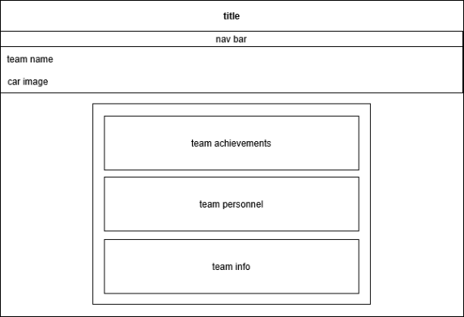
Team details have the team’s achievements, the team principals and the drivers and some team info.
ref:img9

Development:
Database
When I had an idea of what I wanted the website to look like; I got started on setting up the database. Using the official Formula 1 website (https://www.formula1.com/) I gathered up all the information and added it to the databases. Overtime, things were added to it as the project evolved, for example, image names to make adding images easier, especially for images that will be reused. For example, the main driver picture, each driver can have their own one, stored in the database. Slugs were also added later into development to make clean url’s, instead of using the IDs in the link:

ref:img10
ref:img11
ref:img12

Database structure
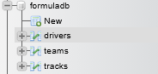
ref:img13
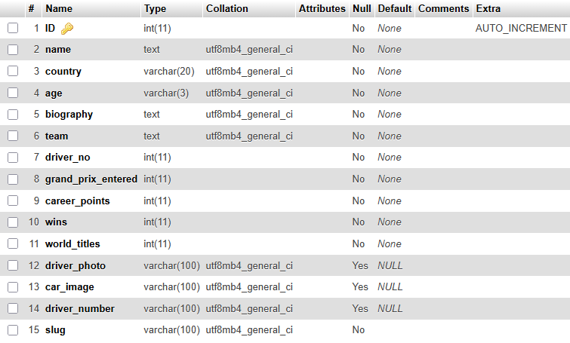
ref:img14
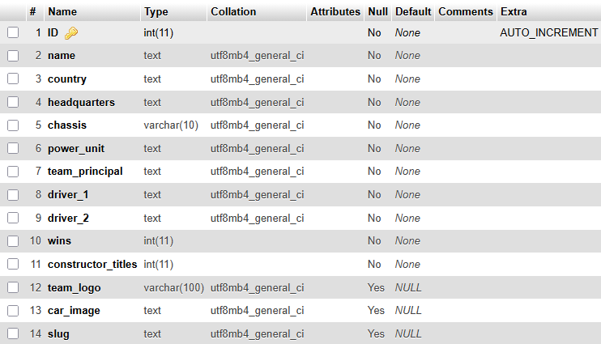
ref:img15
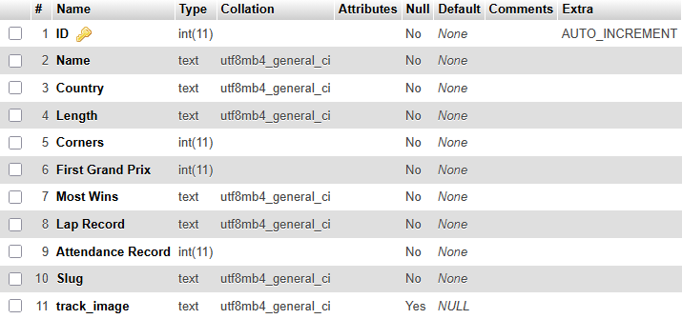
ref:img16

Setting up the pages
Next, I built the three main browse pages. drivers.php was the first one I worked on. At the beginning, it was just a simple HTML table that looped through the drivers using a PHP while loop and displayed the data. It worked, but it looked very basic as it was just rows of text with no real visual appeal. The same approach was used for teams.php and tracks.php. After the list pages were functional, I moved to index.php, the home/landing page.

Home page
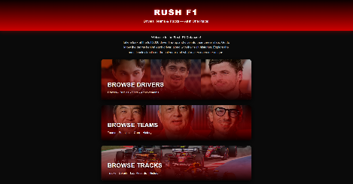
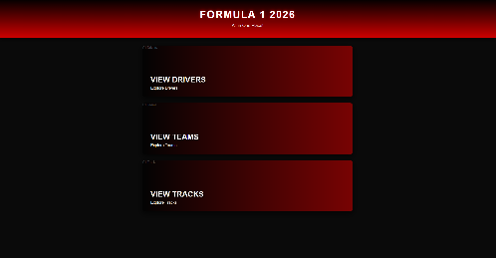
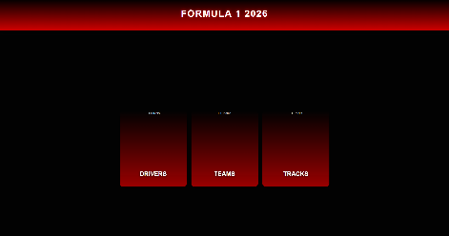
This was where I spent the most time on visual design. I wanted the main navigation on the home page to be 3 large cards, acting as buttons to take you to each individual browse page for drivers, teams, tracks etc. I used images as backgrounds to make it more visually appealing and added a hover effect and a glow, along with a border around the card. I needed to have a paragraph that would introduce the website and give an idea of what its use case would be, so that was added along with a title more fitting with the website.

ref:img17 ref:img18 ref:img19

Driver browse page
I began by replacing the table with a CSS Grid layout. Each driver became its own .driver-card containing their photo at the top and basic information (name, number, and team) below.
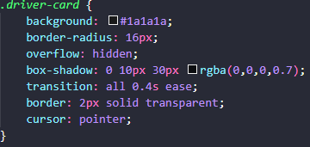
ref:img20
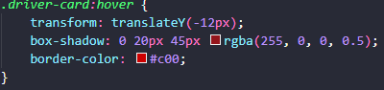
ref:img21
I copied some of the hover effects and dark styling from the homepage to keep the site feeling consistent. At this point the cards looked decent and fitted the rest of the website well, but the driver photos were the biggest problem as most of them were full-body shots, so the cards mainly showed the driver’s chest and racing suit instead of their face. I will talk about the fix for this in a later section.

When creating the database, a slight error I made was not doing it in alphabetical order so when the drivers were displayed, they were displayed in the order they were added to the database. I wanted it to be in alphabetical order as I felt it was the most professional way of doing it. Another idea I had was in team order, like both drivers for Alpine were displayed first etc. To do this I changed the query to “SELECT * FROM drivers ORDER BY name ASC”
Ref:img22

To ensure that responsiveness wasn’t an issue, I needed the boxes and the images to scale correctly for different devices. Larger devices would have more boxes, and smaller ones would have less.
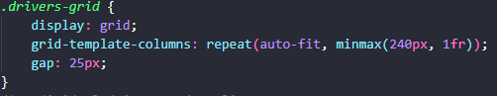
Ref:img23
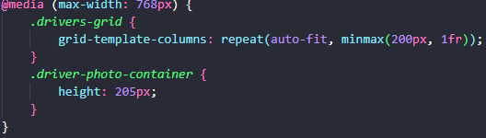
ref:img24
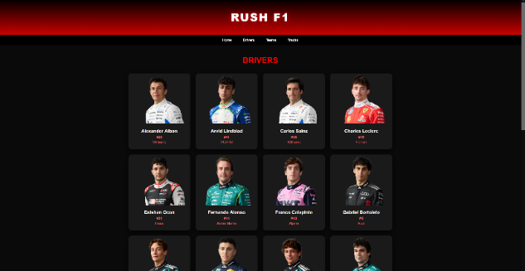

Driver details page

Team browse page

Team details page

Track browse page

Track details page

Testing and Review:
doesn’t scale up to 4k, was only scaled down from 1440p

Reflection and Conclusion:
a

